**scRNA-seq Analysis Report**

Project 19072-23: Cornea Injury Study

*MG53 Knockout Mouse Model*

PI: Dr. Lilian Sakai

OSU Wexner Medical Center, Cardiac Surgery

Date: December 22, 2025

# Executive Summary

This report presents single-cell RNA sequencing analysis of 24,405 cells from mouse corneal tissue, examining MG53 knockout effects in corneal injury using a 2x2 factorial design (Genotype x Injury).

**1. Injury dominates transcriptional changes:** Corneal injury induced 7,179 DEGs compared to 950 for genotype (7.5x difference). The top injury-induced genes include inflammatory markers S100a8 (log2FC=9.3), Ccl3 (log2FC=9.2), Spp1 (log2FC=8.9), and Il1b (log2FC=8.4), while homeostatic genes like Slurp1 (log2FC=-5.7) and Ces1d (log2FC=-6.6) are downregulated.

**2. Immune cell expansion upon injury:** Immune cells increase from 0.29% to 36.16% in WT injured tissue (125x expansion). KO injured tissue shows reduced immune infiltration at 29.65% (18% lower than WT), suggesting MG53 promotes inflammatory recruitment.

**3. Context-dependent MG53 effect:** MG53 knockout shows 920 significant DEGs in injured tissue but only 100 in uninjured (9.2x difference). Top KO-upregulated genes include Trim72 (log2FC=1.35, the MG53 gene itself as expected), Ltf (log2FC=2.17), and Cnfn (log2FC=1.18). Cxcl14 (log2FC=-2.17) is strongly downregulated.

**4. Cell type-specific responses:** Corneal basal epithelial cells show the strongest KO response with 809 significant DEGs. Notably, 583 genes are downregulated vs 226 upregulated, suggesting MG53 normally activates basal cell gene programs. Top affected genes: Cnfn (+2.2), Trim72 (+3.7), Cxcl14 (-2.7), H2-Q7 (-2.9).

**5. Keratinization pathway enrichment:** GO analysis reveals keratinization is 36.5-fold enriched in KO vs WT (11 genes, p<1e-14), with keratinocyte differentiation at 16.0x enrichment (13 genes). This links MG53 to epithelial differentiation control during wound healing.

# Experimental Design

The experiment followed a 2x2 factorial design examining MG53 genotype (Wild-type vs Knockout) and injury status (Uninjured vs Injured) on mouse corneal tissue.

| **Condition** | **Sample** | **Sample ID** | **Cell Count** |
| --- | --- | --- | --- |
| MG53 WT Uninjured | C11 | 19072-23-04-01-01 | 7,297 |
| MG53 WT Injured | C9 | 19072-23-02-01-01 | 5,191 |
| MG53 KO Uninjured | C10 | 19072-23-03-01-01 | 5,896 |
| MG53 KO Injured | C8 | 19072-23-01-01-01 | 6,021 |

Total cells analyzed: 24,405. Data processed with Seurat v5, batch-corrected using Harmony integration across 4 samples.

# Methods

## Data Processing

Raw 10X Genomics data was processed using Cell Ranger and analyzed in R with Seurat v5. Quality control filtering used scuttle::isOutlier with automated thresholds based on MAD (median absolute deviation). Batch effects across 4 samples were corrected using Harmony integration on the first 30 principal components.

## Clustering and Annotation

UMAP dimensionality reduction was performed on Harmony-corrected principal components. Clustering used Seurat's shared nearest neighbor algorithm at resolution 0.3, yielding 25 clusters (0-24). Cell type annotations were provided by Dr. Lilian Sakai based on canonical marker gene expression patterns.

## Differential Expression

DEG analysis used Wilcoxon rank-sum test via Seurat's FindMarkers function. Significance thresholds: adjusted p-value < 0.05, |log2FC| > 0.25 for detection, |log2FC| > 0.5 for reporting significant genes. Minimum cell fraction expressing gene: 10%.

## Pathway Analysis

Gene Ontology Biological Process (GO BP) and KEGG pathway enrichment performed using clusterProfiler (v4.0) with mouse annotation database (org.Mm.eg.db). Background: all detected genes. Significance: Benjamini-Hochberg adjusted p < 0.05.

# Results

## Cell Type Identification

Twelve distinct cell populations were identified across 25 clusters. Corneal epithelial cells comprise the largest population (10,896 cells, 44.65%), followed by immune cells (3,702 cells, 15.17%) and transient amplifying cells (2,846 cells, 11.66%). Rare populations include Schwann cells (136, 0.56%), myofibroblasts (124, 0.51%), and endothelial cells (109, 0.45%).

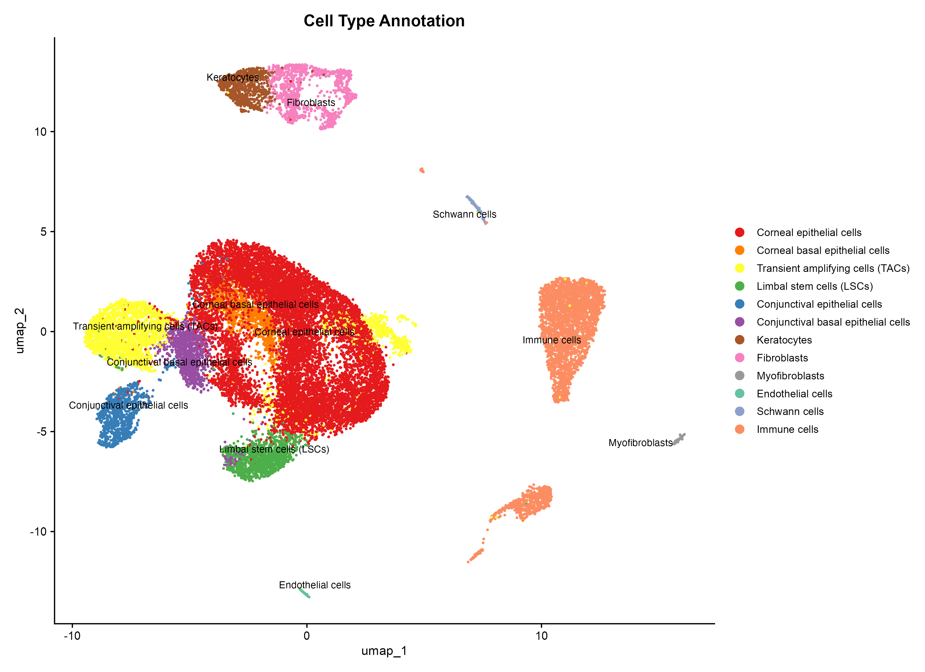

*Figure 1. UMAP visualization of 24,405 cells colored by cell type. Corneal epithelial cells form the dominant central cluster (44.65%). Immune cells cluster separately on the right (15.17%).*

### Cell Type Distribution

| **Cell Type** | **Count** | **Percentage** |
| --- | --- | --- |
| Corneal epithelial cells | 10,896 | 44.65% |
| Immune cells | 3,702 | 15.17% |
| Transient amplifying cells (TACs) | 2,846 | 11.66% |
| Limbal stem cells (LSCs) | 1,288 | 5.28% |
| Corneal basal epithelial cells | 1,275 | 5.22% |
| Fibroblasts | 1,211 | 4.96% |
| Conjunctival basal epithelial cells | 1,084 | 4.44% |
| Conjunctival epithelial cells | 943 | 3.86% |
| Keratocytes | 791 | 3.24% |
| Schwann cells | 136 | 0.56% |
| Myofibroblasts | 124 | 0.51% |
| Endothelial cells | 109 | 0.45% |

## Cell Composition Changes with Injury

Corneal injury induces dramatic shifts in cell type composition. The most striking change is massive immune cell infiltration, accompanied by proportional reduction of epithelial cells.

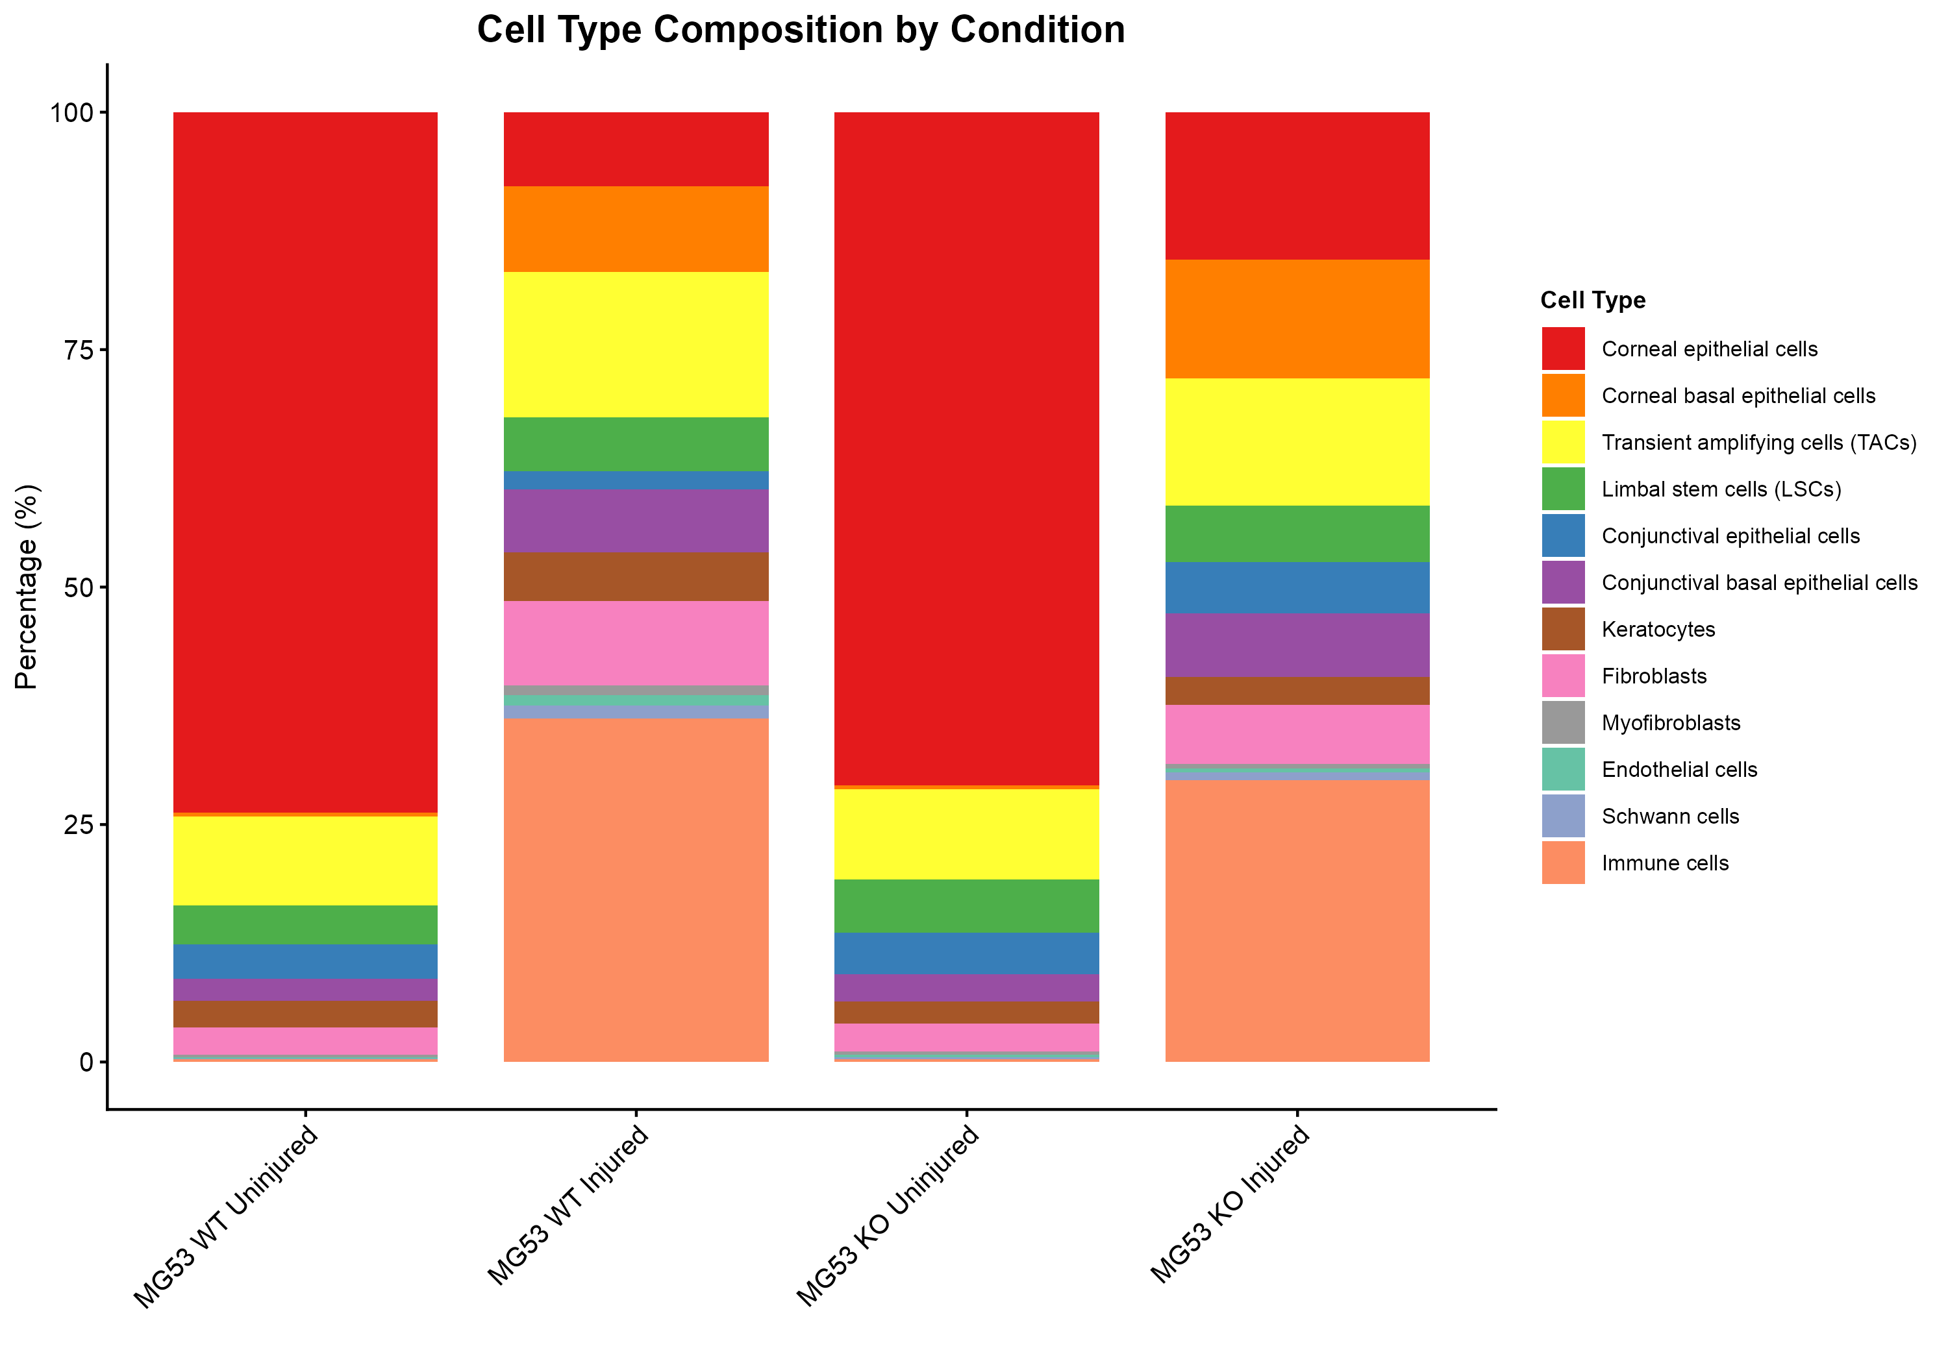

*Figure 2. Cell type composition across 4 conditions. Immune cells expand from 0.29% (WT Uninjured) to 36.16% (WT Injured). Note reduced immune infiltration in KO Injured (29.65%).*

### Quantitative Composition Changes

**Immune cell expansion:** WT Uninjured: 0.29% vs WT Injured: 36.16% (125-fold increase). KO Injured shows 29.65%, which is 18% lower than WT Injured, suggesting MG53 promotes immune infiltration.

**Epithelial cell reduction:** Corneal epithelial cells decrease from 73.73% (WT Uninjured) to 7.82% (WT Injured) as immune cells infiltrate. KO Injured maintains higher epithelial proportion at 15.50%.

**Basal cell mobilization:** Corneal basal epithelial cells increase from 0.40% (WT Uninjured) to 8.98% (WT Injured), consistent with basal cell activation during wound healing. KO Injured shows 12.56%.

**Pattern:** Injury response is qualitatively similar between WT and KO, but KO shows reduced immune infiltration and higher epithelial retention. This suggests MG53 modulates the injury response rather than being essential for it.

## Condition Comparison

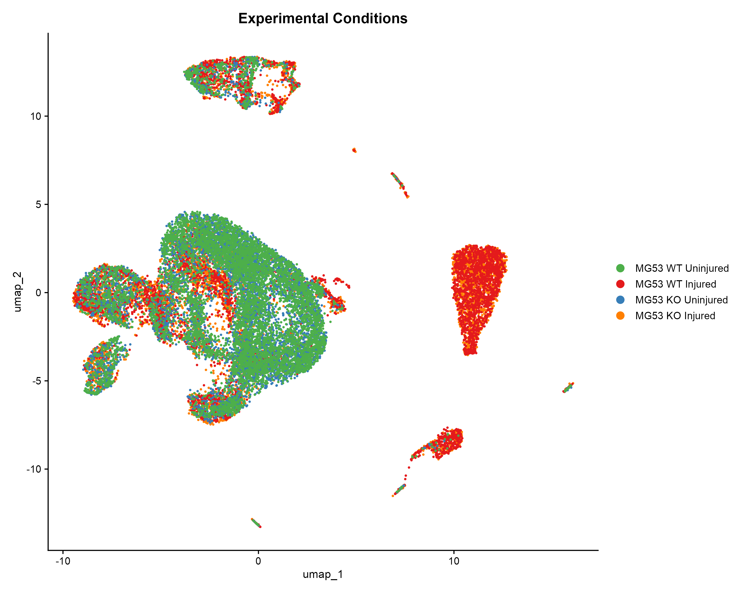

*Figure 3. UMAP colored by experimental condition. Injured samples (C8, C9) show expanded immune clusters. Uninjured samples (C10, C11) show compact epithelial architecture.*

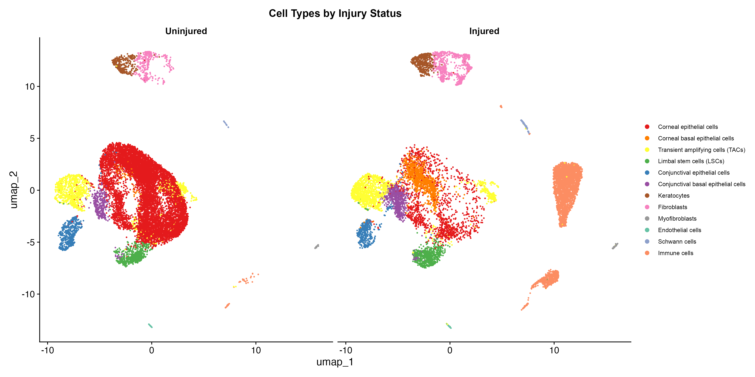

*Figure 4. UMAP split by injury status. Note the massive expansion of immune cell clusters (right side) in injured tissue.*

## Marker Gene Validation

Cell type identities were validated using established corneal marker genes:

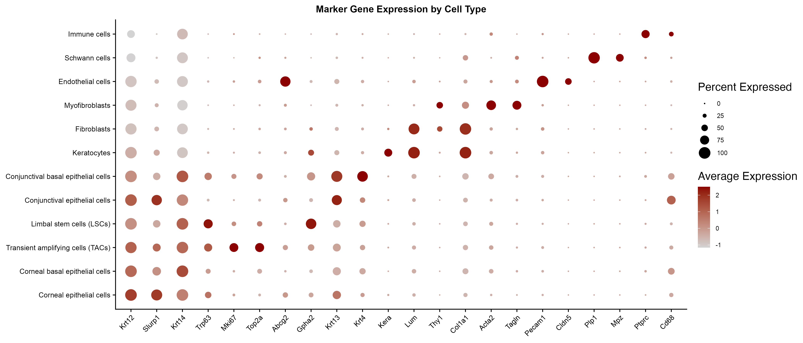

*Figure 5. Marker gene expression by cell type. Krt12/Slurp1: corneal epithelium; Krt14/Trp63: basal cells; Ptprc/Cd68: immune; Kera/Lum: keratocytes.*

## Differential Expression Analysis

DEG analysis reveals injury as the dominant driver of transcriptional changes (7,179 DEGs), with genotype effects amplified specifically in the injury context (920 vs 100 significant DEGs).

### Overall DEG Summary

| **Comparison** | **Total DEGs** | **Up** | **Down** |
| --- | --- | --- | --- |
| Injured vs Uninjured (Overall) | 7,179 | 2,450 | 2,225 |
| KO vs WT (Overall) | 950 | 97 | 68 |
| KO vs WT (Injured only) | 3,384 | 555 | 365 |
| KO vs WT (Uninjured only) | 628 | 42 | 58 |
| Injured vs Uninjured (KO) | 7,125 | 2,266 | 2,170 |
| Injured vs Uninjured (WT) | 7,378 | 2,421 | 2,345 |

**Critical finding:** KO vs WT comparison yields 920 significant DEGs (|log2FC|>0.5, padj<0.05) in injured tissue vs only 100 in uninjured tissue (9.2x ratio). This demonstrates that MG53 function is injury-activated rather than required for homeostasis.

### Top Differentially Expressed Genes

**Injury response (top upregulated):** S100a8 (log2FC=9.3), Xist (12.8), Ccl3 (9.2), Spp1 (8.9), Il1b (8.4), Ppbp (7.9), Ccl4 (7.3), Cxcl3 (7.0). These represent acute inflammatory and wound healing signatures.

**Injury response (top downregulated):** Eif2s3y (log2FC=-12.9, Y-chromosome gene reflecting sample sex), Cyp4a12b (-7.1), Ces1d (-6.6), Slurp1 (-5.7, corneal homeostasis marker), Dsg1a (-5.4). Downregulation of epithelial homeostasis genes reflects tissue remodeling.

**MG53 KO effect (upregulated):** Psca (log2FC=0.33), Trim72 (1.35, MG53 gene itself), Cnfn (1.18), Ltf (2.17, antimicrobial). Upregulation of Cnfn suggests compensatory keratinization.

**MG53 KO effect (downregulated):** Cxcl14 (log2FC=-2.17, chemokine), 9330111N05Rik (-2.17), H2-Q7 (-1.52, MHC class I). Reduced immune-related gene expression aligns with lower immune infiltration in KO.

### Volcano Plots

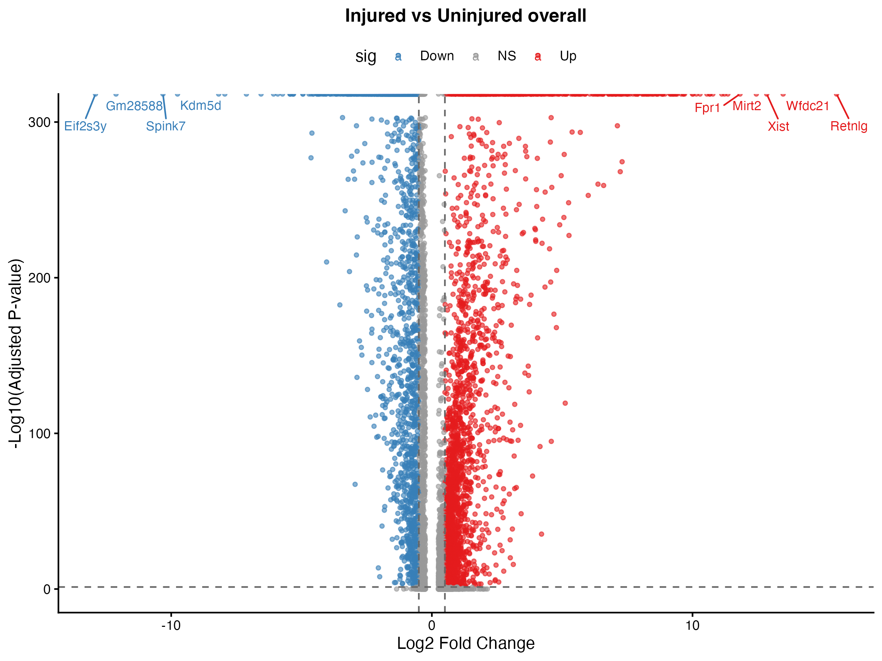

*Figure 6. Injured vs Uninjured overall. 4,675 significant DEGs with log2FC ranging from -13 to +13. Top genes: S100a8, Xist, Ccl3 (up); Eif2s3y, Cyp4a12b (down).*

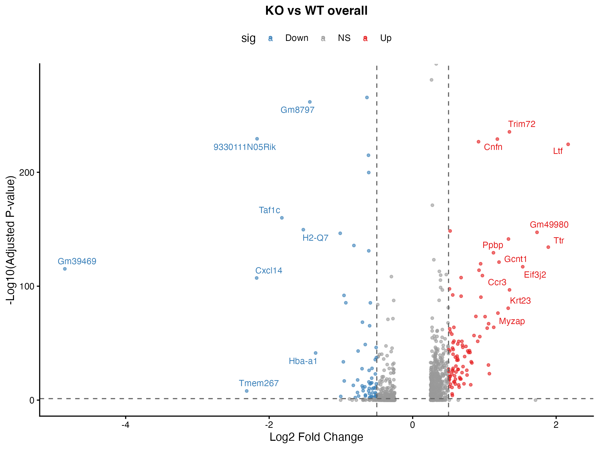

*Figure 7. KO vs WT overall. 165 significant DEGs with modest fold changes (log2FC -2 to +2). Top: Trim72, Ltf (up); Cxcl14 (down).*

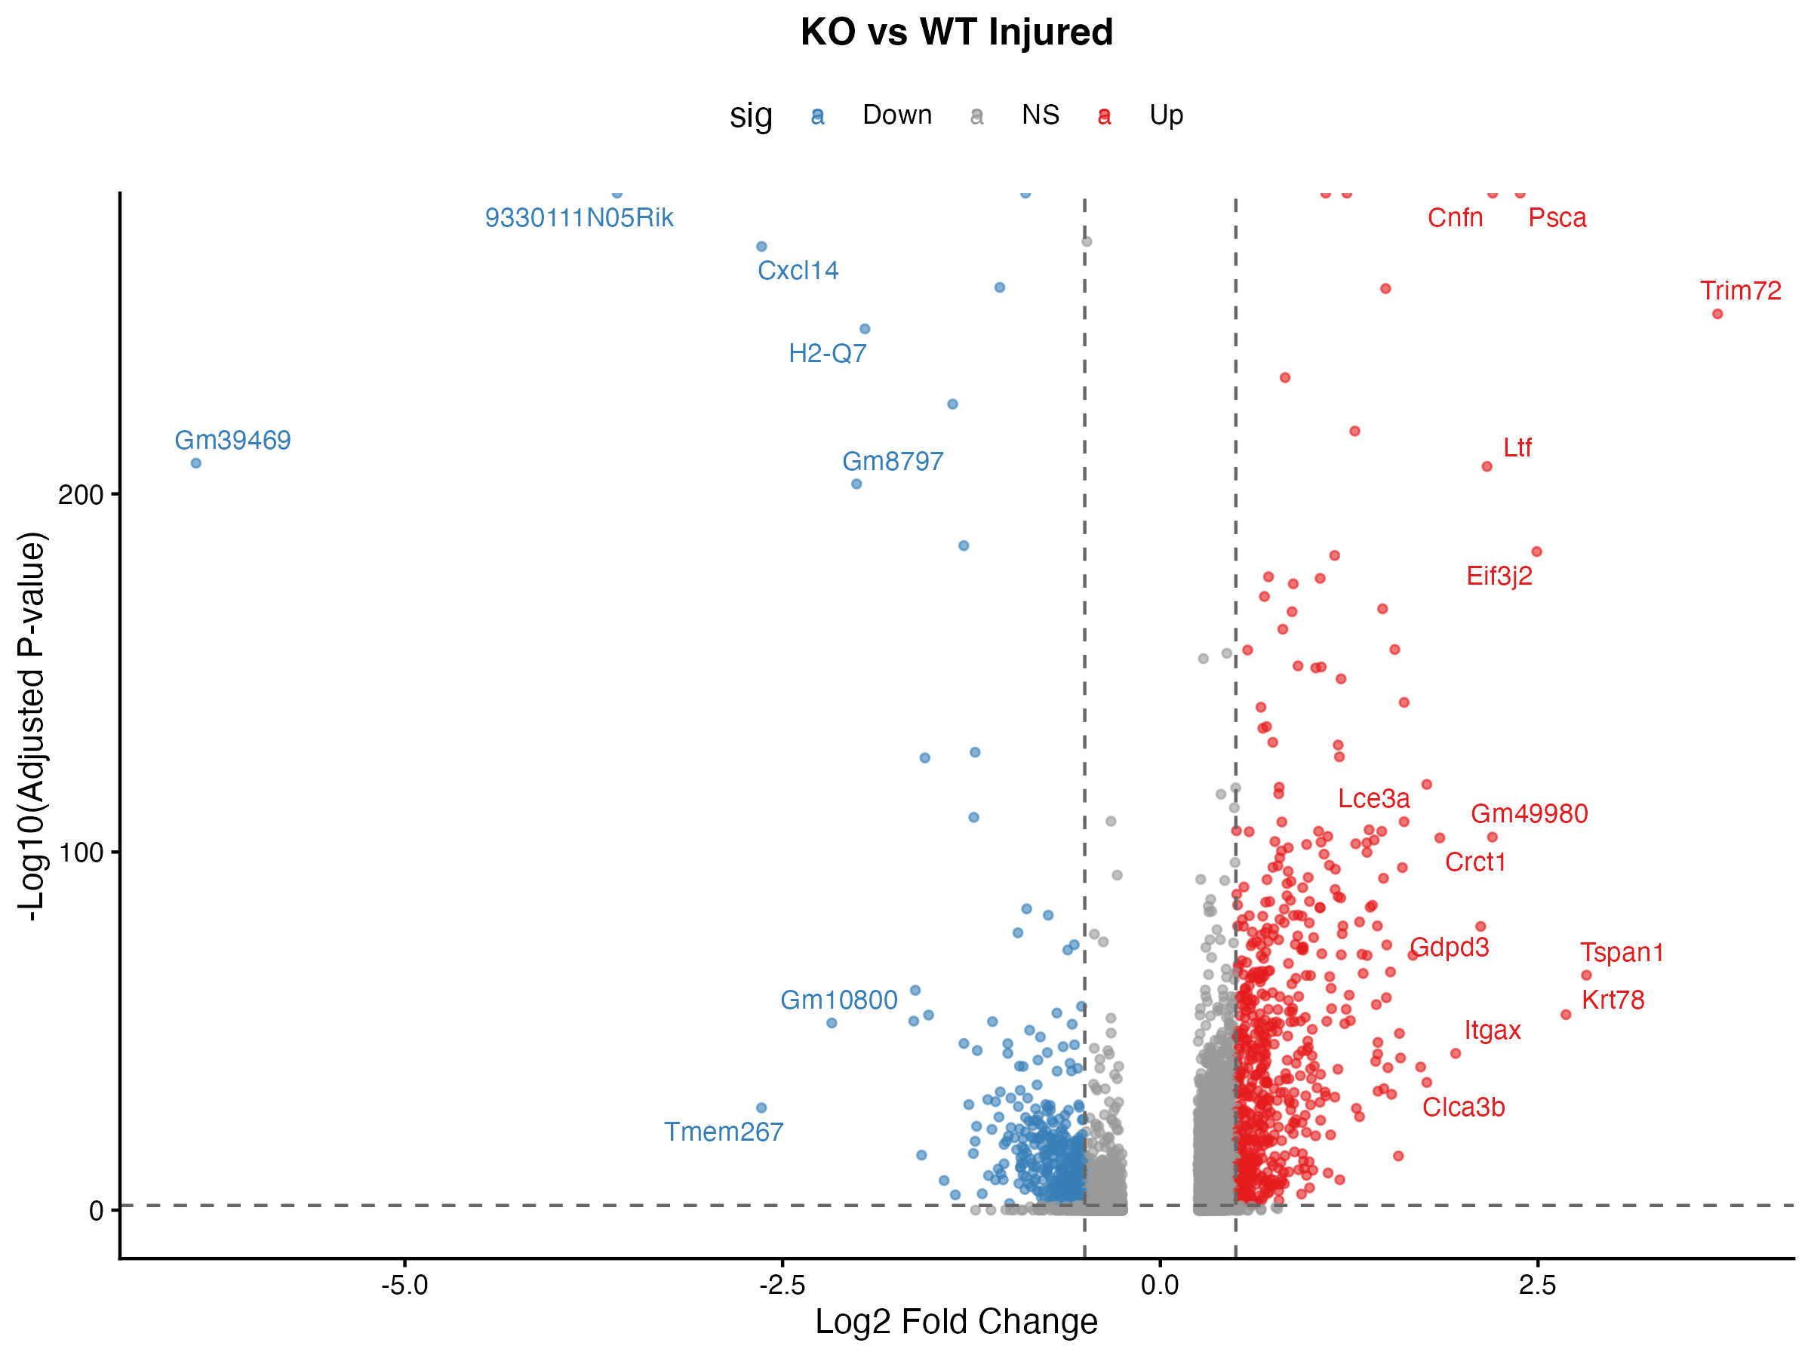

*Figure 8. KO vs WT in injured tissue only. 920 significant DEGs show enhanced genotype effect in injury context (9.2x more than uninjured).*

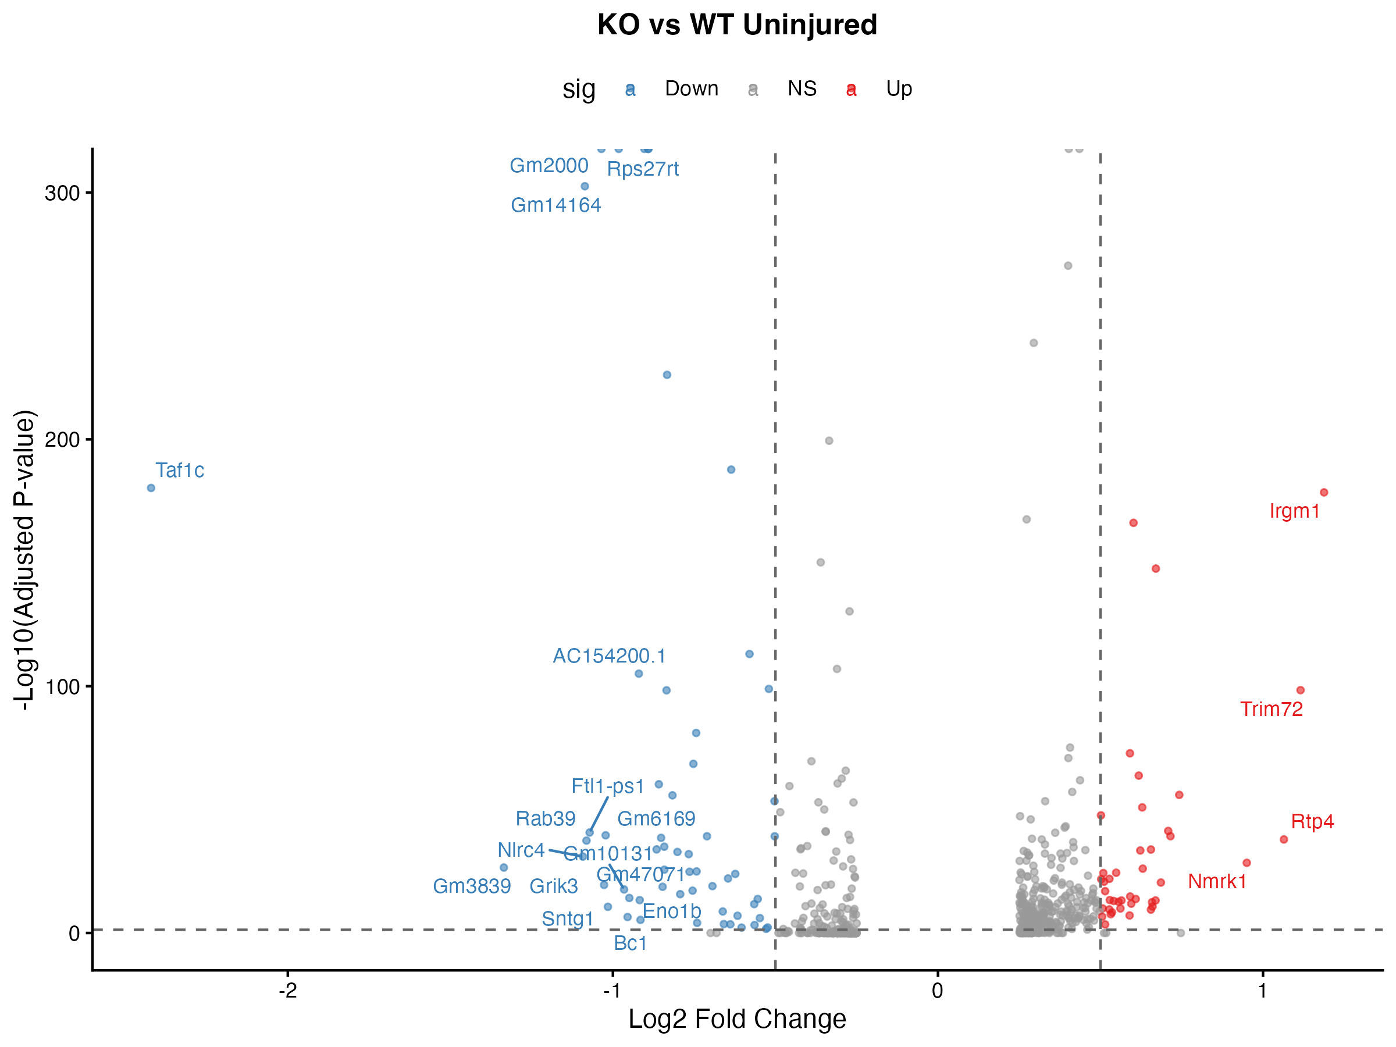

*Figure 9. KO vs WT in uninjured tissue. Only 100 significant DEGs, confirming MG53 function is largely injury-dependent.*

### Cell Type-Specific MG53 KO Effects

Per-cell-type DEG analysis reveals heterogeneous MG53 knockout effects, with epithelial cells showing the strongest responses:

| **Cell Type** | **Total DEGs** | **Up** | **Down** |
| --- | --- | --- | --- |
| Corneal basal epithelial | 5,587 | 226 | 583 |
| Conjunctival epithelial | 3,713 | 227 | 116 |
| Fibroblasts | 3,000 | 71 | 35 |
| TACs | 1,986 | 59 | 28 |
| LSCs | 1,987 | 33 | 34 |
| Immune cells | 1,253 | 67 | 62 |
| Corneal epithelial | 884 | 151 | 53 |

**Corneal basal epithelial cells:** Most affected by MG53 KO with 809 significant DEGs. Strikingly, 583 are downregulated vs 226 upregulated (2.6:1 ratio), suggesting MG53 normally activates rather than represses basal cell gene programs. Top upregulated: Cnfn (log2FC=2.2), Trim72 (3.7), Eif3j2 (3.3). Top downregulated: 9330111N05Rik (-4.7), Cxcl14 (-2.7), Ifi27l2a (-3.2), H2-Q7 (-2.9).

## Pathway Enrichment Analysis

GO Biological Process and KEGG pathway analysis identifies functional themes enriched in differentially expressed genes.

### MG53 KO Pathway Signatures

GO enrichment for KO vs WT (overall) reveals striking epithelial differentiation signatures:

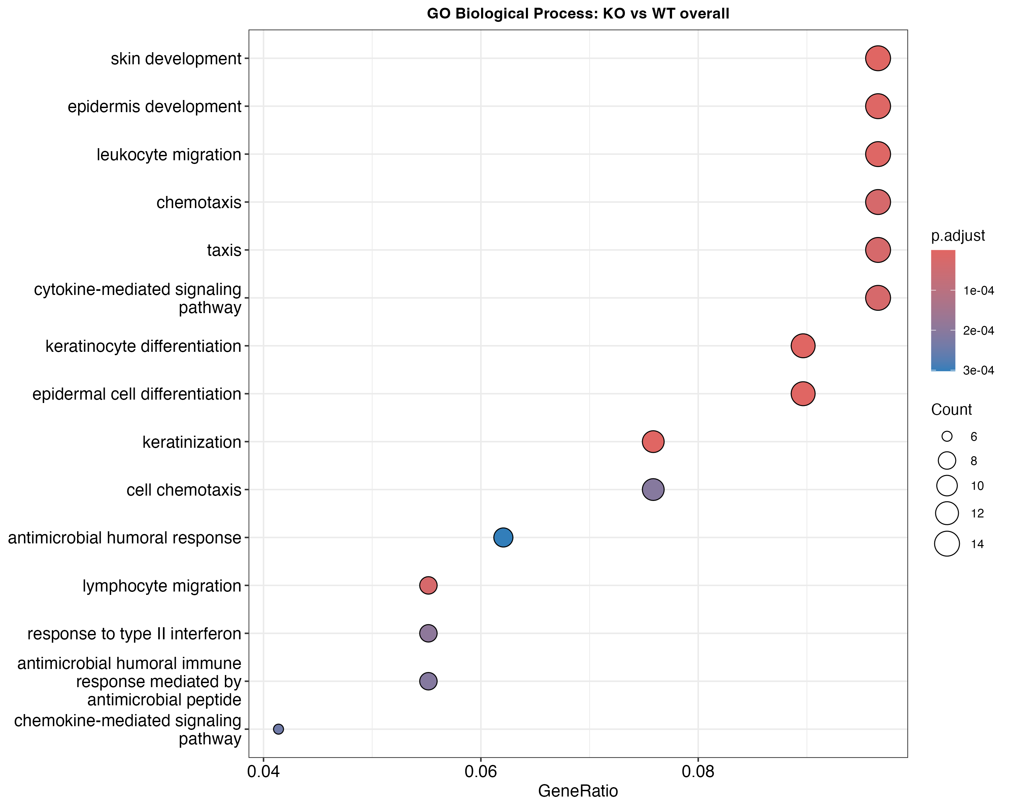

*Figure 10. GO BP for KO vs WT overall. Keratinization (36.5x), keratinocyte differentiation (16.0x), and skin development (8.2x) are highly enriched.*

**Keratinization:** 36.5-fold enrichment (11 genes, p=9.6e-15). Genes: Cnfn, Sprr2d, Sprr2f, Sprr2i, Sprr2h, Krt7, Sprr1b, Sprr2e, Tgm1, Krt78, Abca12. This represents the strongest pathway signature of MG53 loss.

**Keratinocyte differentiation:** 16.0-fold enrichment (13 genes, p=2.0e-12). Adds Krt14 and Pou2f3 to keratinization genes, indicating broad epithelial differentiation dysregulation.

**Leukocyte migration:** 6.9-fold enrichment (14 genes, p=1.7e-8). Genes: Ppbp, Cxcl14, Ccr3, Ecm1, Il33, Ccl7, Ccl2, Itgam, Ccl4. Altered immune cell recruitment aligns with reduced infiltration in KO.

**Type II interferon response:** 10.7-fold enrichment (8 genes, p=9.1e-7). Genes: H2-Q7, Ifitm1, Arg1, Irgm1, Ccl7, Ccl2, Bst2, Ccl4. Reduced interferon signaling may explain altered immune phenotype.

### Injury Response Pathways

GO enrichment for Injured vs Uninjured (WT) identifies canonical wound healing signatures:

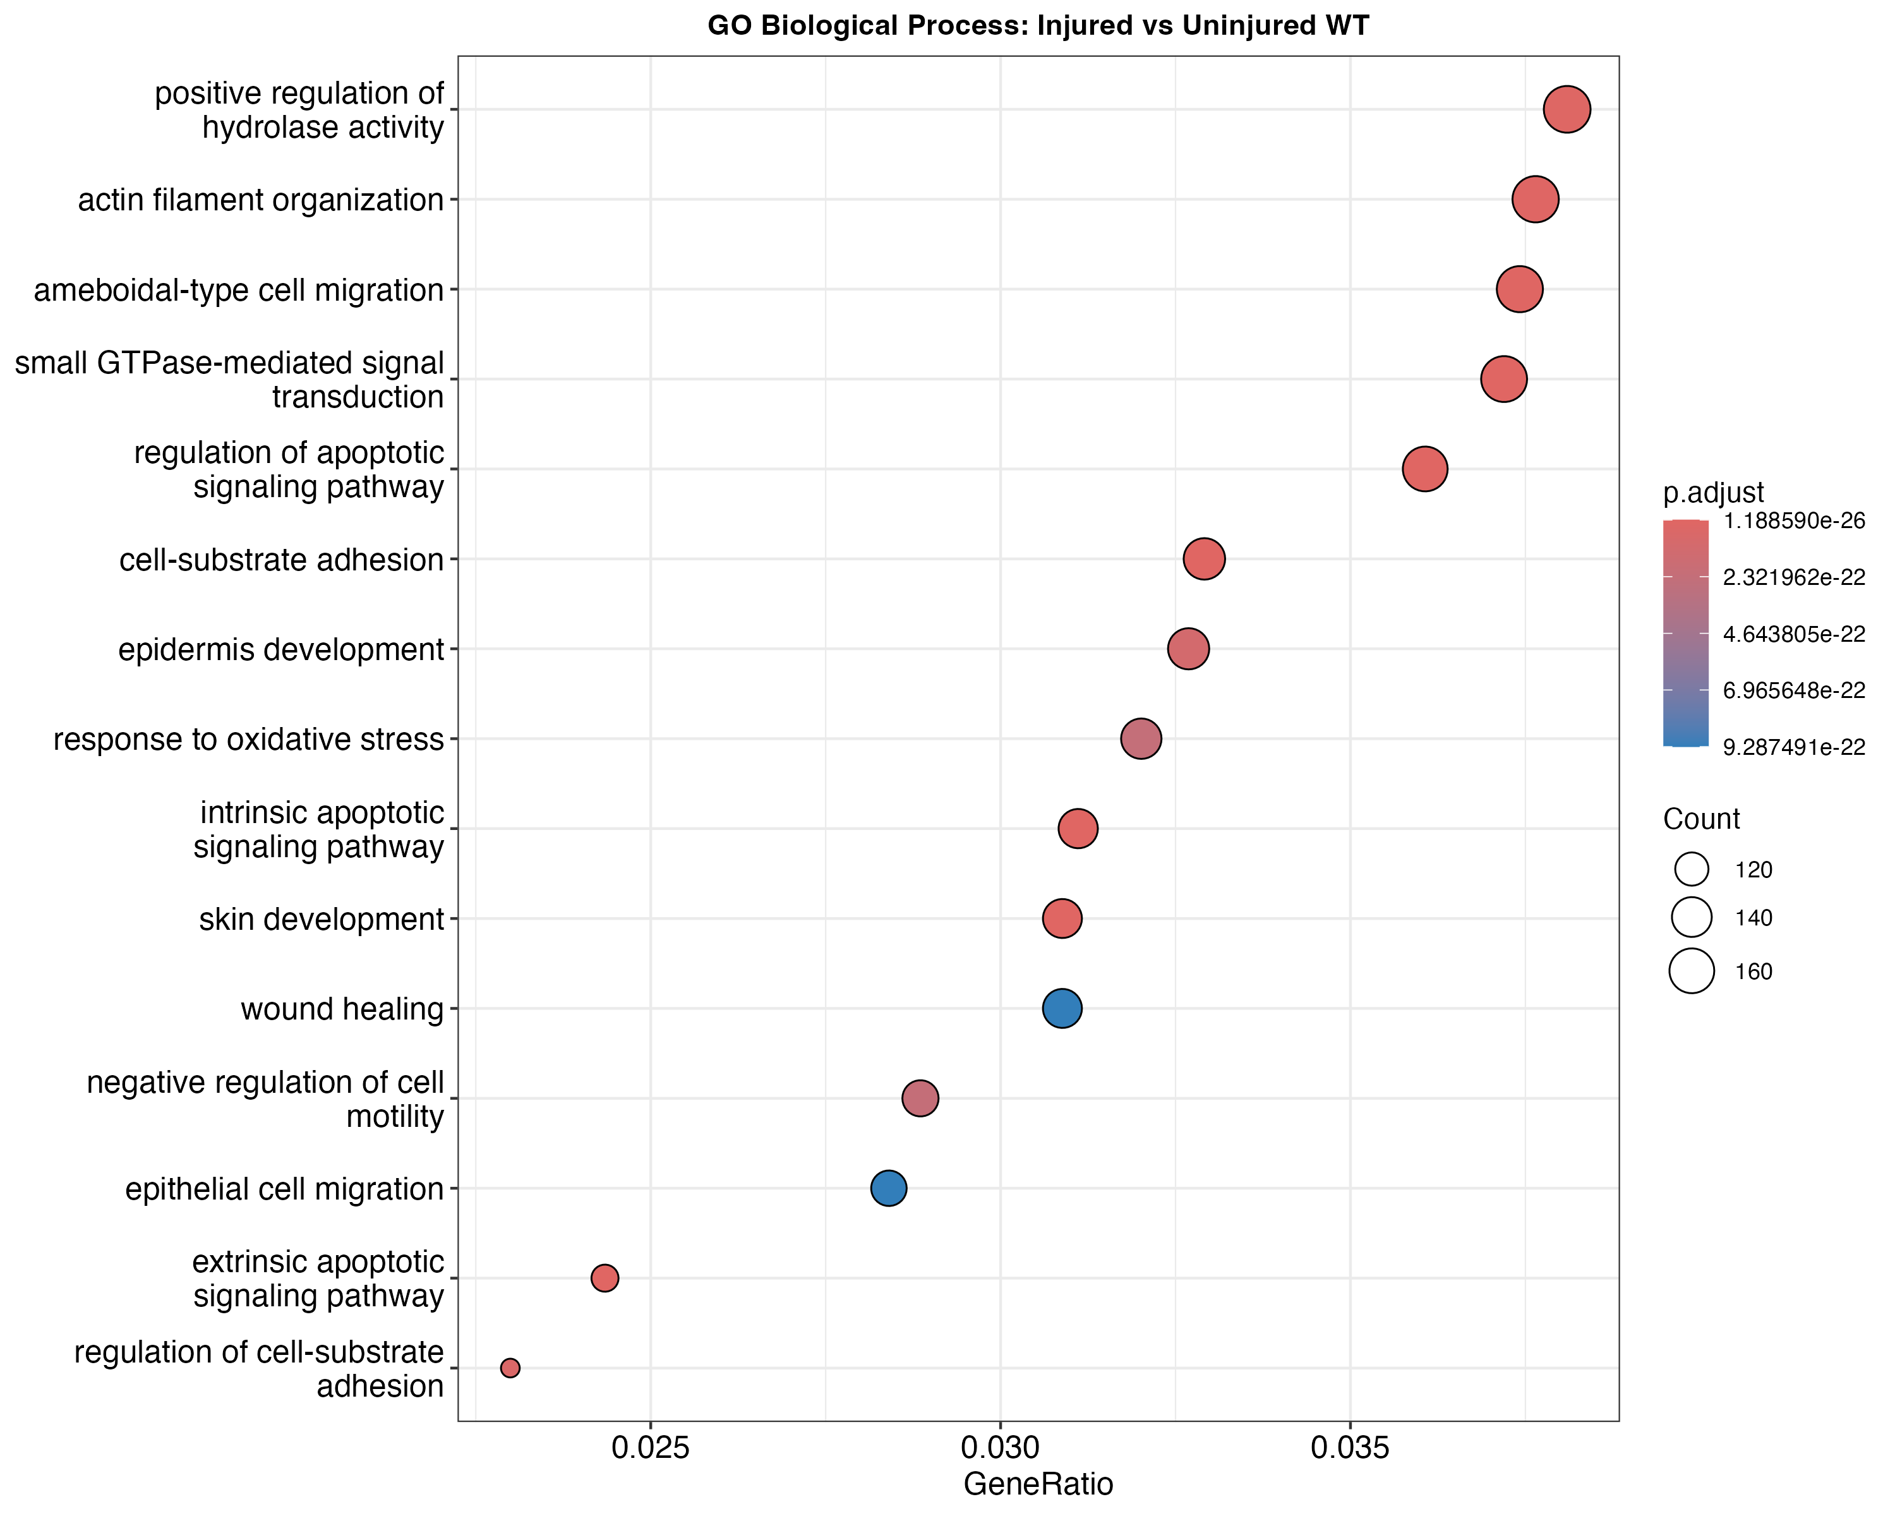

*Figure 11. GO BP for injury response in WT. Small GTPase signaling (2.4x, 165 genes), cell-substrate adhesion (2.6x, 146 genes), and apoptotic signaling (2.7x, 138 genes) dominate.*

**Small GTPase signaling:** 2.4-fold enrichment (165 genes, p=1.9e-30). Central to cell migration and cytoskeletal remodeling during wound healing.

**Cell-substrate adhesion:** 2.6-fold enrichment (146 genes, p=7.7e-30). Reflects ECM remodeling and cell migration.

**Apoptotic signaling:** 2.7-fold enrichment (138 genes, p=6.4e-30). Both intrinsic and extrinsic pathways activated, consistent with tissue damage and inflammatory cell turnover.

**Skin/epidermis development:** 2.6-fold enrichment (137 genes, p=1.0e-28). Includes keratins, junction proteins, and differentiation factors.

**Actin filament organization:** 2.3-fold enrichment (167 genes, p=1.0e-26). Cell motility and cytoskeletal dynamics.

**Leukocyte migration:** 2.3-fold enrichment (140 genes, p=2.3e-22). Chemokines (Ccl2, Ccl3, Ccl4, Cxcl2, Cxcl3, Cxcl5) drive immune infiltration.

### KEGG Pathway Analysis

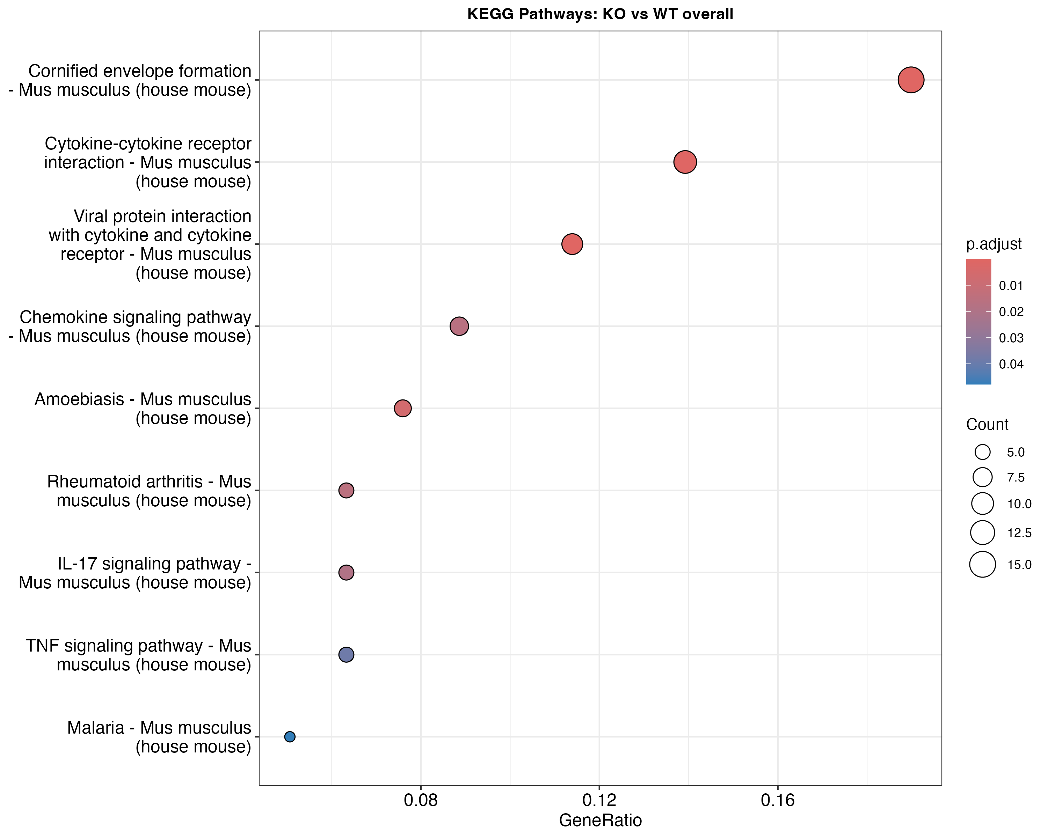

*Figure 12. KEGG pathways in KO vs WT. Metabolic and signaling pathways affected by MG53 loss.*

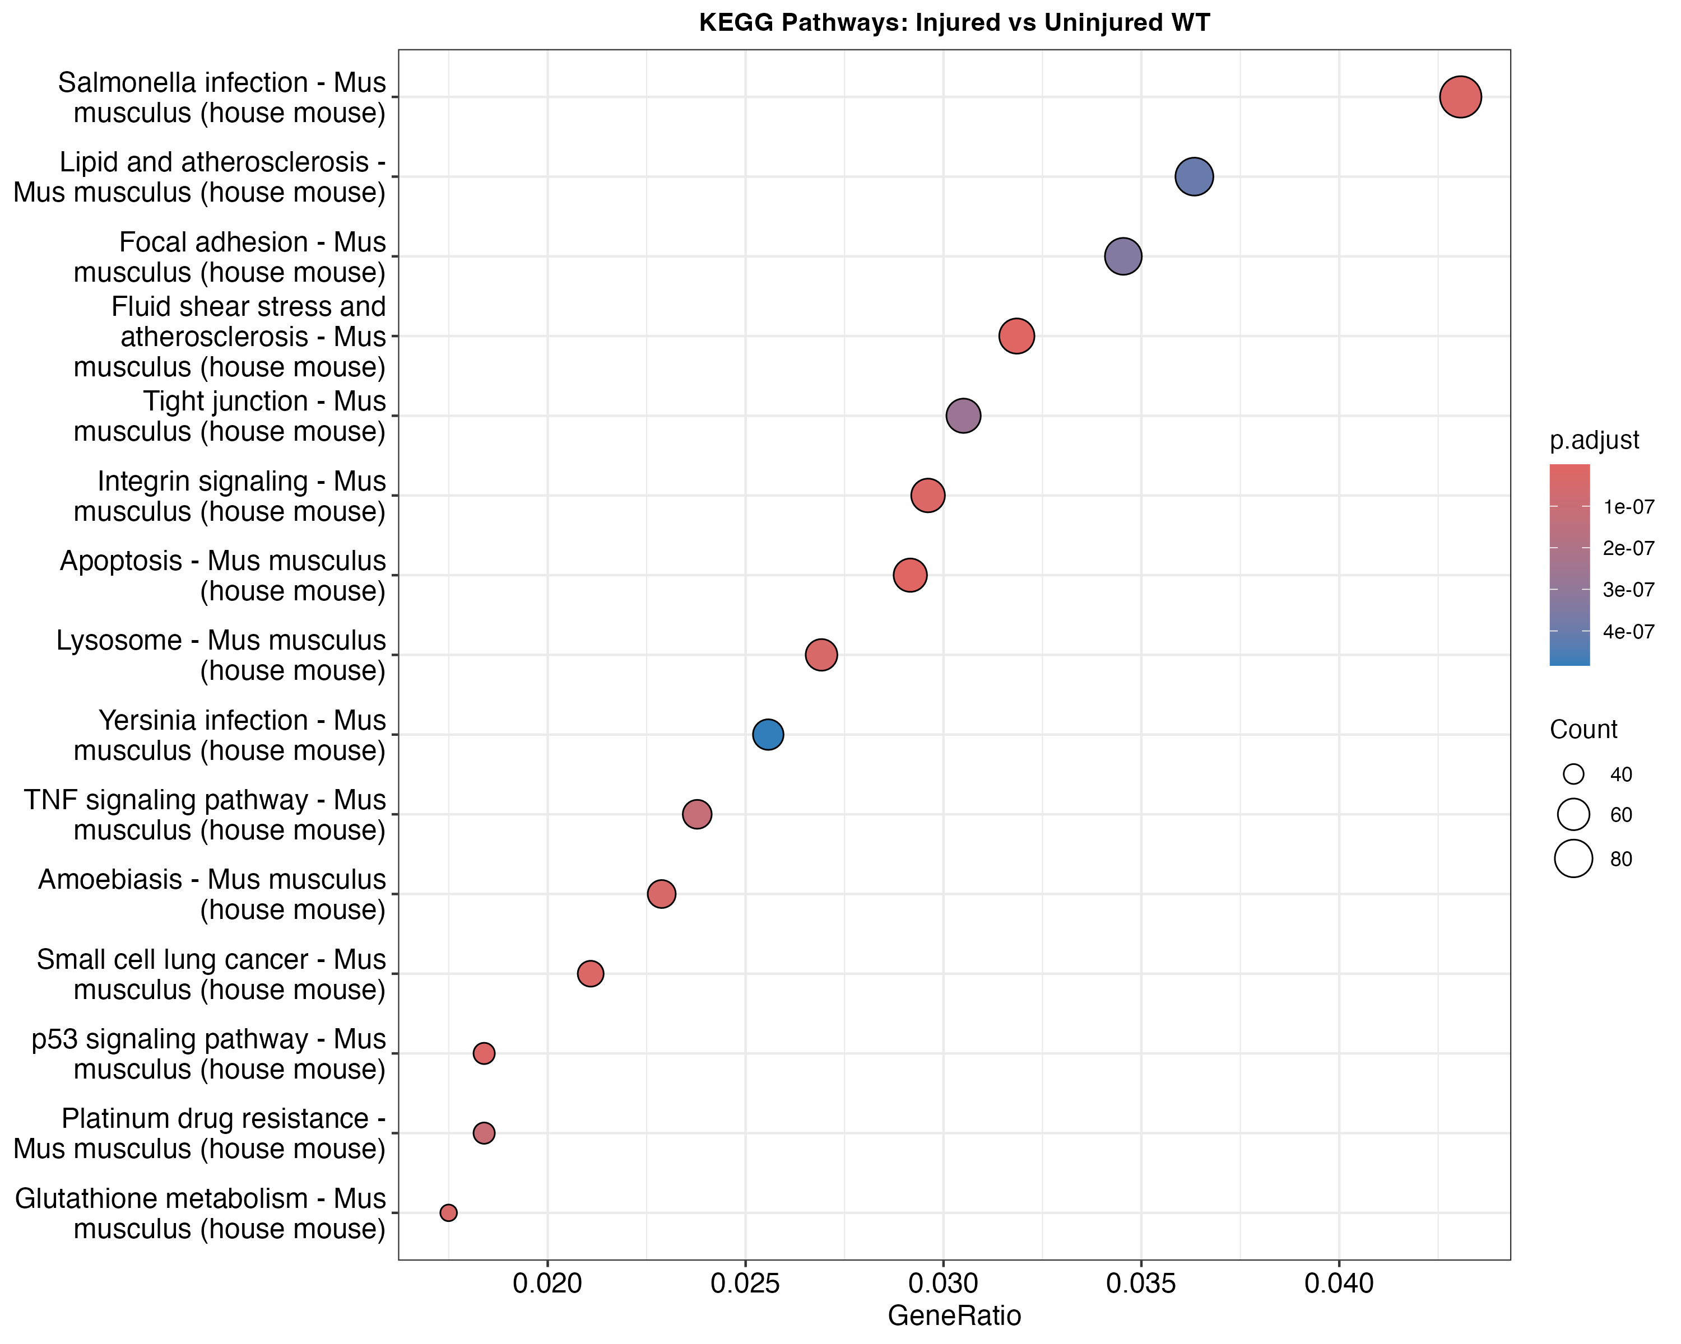

*Figure 13. KEGG pathways in injury response. Cytokine-cytokine receptor interaction, TNF signaling, and IL-17 signaling drive inflammatory response.*

# Conclusions

This single-cell transcriptomic analysis of 24,405 corneal cells from MG53 knockout and wild-type mice reveals context-dependent gene regulatory functions:

**1. Injury-activated function:** MG53 effects are 9.2x stronger in injured tissue (920 vs 100 significant DEGs). This indicates MG53 is functionally important during wound response rather than steady-state homeostasis. The modest phenotype in uninjured cornea suggests compensatory mechanisms maintain tissue integrity.

**2. Epithelial cell specificity:** Corneal basal epithelial cells show the strongest response to MG53 loss (809 DEGs), with predominantly downregulated genes (2.6:1 ratio). Top affected genes include keratinization factors (Cnfn, Sprr family), suggesting MG53 normally promotes epithelial differentiation programs.

**3. Keratinization regulation:** The 36.5-fold enrichment of keratinization genes (p<1e-14) is the most striking molecular signature of MG53 loss. Combined with 16x enrichment of keratinocyte differentiation, this identifies MG53 as a regulator of epithelial maturation during wound healing.

**4. Immune modulation:** Reduced immune cell infiltration in KO injured tissue (29.65% vs 36.16%, 18% reduction) combined with downregulated chemokines (Cxcl14, Ccl4) and MHC genes (H2-Q7) suggests MG53 promotes inflammatory recruitment. The reduced interferon response signature (10.7x enrichment) further supports this.

**5. Therapeutic implications:** These findings position MG53 as a regulator of corneal epithelial differentiation and wound-associated inflammation. Enhancing MG53 activity could potentially improve corneal wound healing by promoting epithelial regeneration and appropriate inflammatory responses.

The injury-dependent nature of MG53 function provides mechanistic insight into why this membrane repair protein primarily affects tissue during damage rather than homeostasis.

# Data Availability

Analysis outputs are organized in the following directories:

- Figures: rmd3/report_12222025/figures/ (PNG and SVG formats, 300 dpi)

- Tables: rmd3/report_12222025/tables/ (CSV format)

- Seurat objects: rmd3/objects/ (qsave and RDS formats)

- Interactive portal: https://bmblx.bmi.osumc.edu/scrnaseq_huazhu_cornea/

Analysis scripts: a2_celltype_annotation.R (cell typing), a3_deg_pathway.R (differential expression and pathways)

Key output files:

- proj23_DEG_summary.csv - Summary of all DEG comparisons

- proj23_DEG_all_comparisons.csv - Full DEG results

- proj23_GO_BP_*.csv - GO Biological Process enrichment results

- proj23_KEGG_*.csv - KEGG pathway enrichment results

- proj23_celltype_by_condition.csv - Cell composition tables